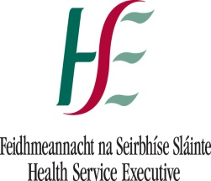

An Information and Communications Technology Strategy for Healthcare

Version 2.5.6
April 2011

Contents

1 Executive summary 1
1.1 Vision 1
1.2 Strategic Initiatives 1
1.3 Principles 2
1.4 Strategic Goals 3
1.5 Translating the Vision into Reality 3
1.6 Governance 3
1.7 Strategic Programmes 4
1.8 Challenges 5
1.9 Opportunities 5
2 Introduction 6
3 Future Healthcare System 7
3.1 HSE Corporate Plan 7
3.2 An Integrated Health and Social Care Model 8
3.3 Environment 8
3.4 Organisation 9
3.5 Delivery 11
3.6 Funding and Resourcing 12
3.7 Implications for ICT strategy 12
3.8 Lessons learned from previous ICT strategies in Ireland 14
4 Vision for ICT 16
4.1 Vision Statement 16
4.2 Principles 16
4.3 Strategic Goals 16
4.4 ICT Objectives 16
4.5 Critical Dependencies 21
5 Translating the Vision into Reality 22
5.1 Rationalisation of ICT Technical Infrastructure 22
5.1.1 Technical Principles 22
5.1.2 Technical Architecture 23
5.2 Rationalisation of existing/ legacy applications 24
5.3 ICT Application Services 24
5.4 Implementation of Core hospital systems 26
5.5 Integration of Primary Care 26
5.6 Expansion of Corporate and Operational Support Systems 28
5.6.1 Enterprise Resource Planning (ERP) Systems 28
5.6.2 Support for Corporate Planning and the Business Intelligence Unit 28
5.6.3 Business Process Reengineering, e-Business and e-Government 29
5.7 ICT support for the National Clinical Care Programmes 29
5.8 Pre Hospital Emergency Care Systems 30
5.9 National Child Care Systems 31
5.10 Public Health Systems 31
5.11 Quality, Risk & Safety Systems 31
5.12 National Cancer Control Programme Systems 31
5.13 Demand Led Schemes (PCRS) 32
5.14 Community and Continuing Care Systems 32
5.15 The Electronic Health Record 32
5.16 E-Health 34
5.17 Other Services and Agencies 34
6 Implementing the ICT Strategy 36
6.1 Governance 36
6.2 Governing Principles 36
6.3 Funding 37
6.4 Procurement 38
6.5 Staffing 39
6.6 Projects 39
6.7 ICT Project Approval Process 39
6.8 ICT Project Methodology 39
6.9 Project Governance 40
6.10 ICT Programme Management Office 41
6.11 Delivering Benefit 41
6.12 Risk Management 41
6.13 Implementation plan 42

Executive summary

This document sets out a long term vision for the use of ICT in healthcare and personal social services in Ireland and the strategy to activate that vision. In accordance with this, the strategy sets out plans for the period from 2011 to 2016 and it sets out a framework in which investment decisions can be made.

There is a growing demand for greater exploitation of ICT in healthcare, to improve safety, effectiveness and efficiency, to contain costs, to maintain information on individuals and groups across the population and to improve record-keeping and accessibility to information.

The ICT strategy is driven by the overall strategy and objectives of the Health Services Executive (HSE) as expressed in the Corporate Plan and Annual Service Plans.

Vision
The ICT Vision for the Health Service Executive is:

To deliver sustainable improvements in health and social care for patients and clients, via the deployment of cost effective, standards based, secure technology and applications, that provide access to meaningful, timely, and relevant information, when and where it is required.

Although the focus of this strategy is on the next five years, it is derived from the overall direction for healthcare ICT and it sets out the major goals to be achieved.

Strategic Initiatives
The ICT Strategy has identified a number of strategic initiatives, the purpose of which is to align ICT projects and services with the strategic objectives of the organisation. These objectives are:

Health and Wellbeing
We will invest in preventing illness; supporting, encouraging and empowering people to pursue independent, healthy and fulfilling lifestyles to reduce the likelihood of illness. We will ensure that early diagnosis, treatment and care options are available, if required.

Sustainable Services
We will reconfigure our services to develop sustainable hospital and community services that provide the care people need now, and in the future. By delivering the majority of care in the community, we will enable hospitals to focus on improving accessibility to deliver more efficient acute and planned care.

Operational Excellence
We will achieve operational excellence using processes and systems that are efficient, easy for service users to access and understand, evidence based and deliver value for money.

Unlocking Our Potential
We will actively support and encourage all staff to achieve their full potential and deliver quality care. In partnership, we will recognise and celebrate achievements and encourage staff to work responsibly, manage challenges and take pride in their contribution to the services they provide on behalf of the organisation.

Quality and Safety
We will ensure the quality and safety of our services. By developing a transparent quality and safety culture and adapting our work practices, we will ensure that continuous quality and safety improvement is integral to all that we do.

Trust and Confidence
We will build the public’s trust and confidence in our health services through the provision of timely, well integrated, professional and accessible services. We will make it easier for people to access the right service, in the right place, at the right time.

Principles
To support and enable the provision of quality healthcare ICT will:-

- Be patient/client centric
- Support clinical practice
- Provide access to information when and where required
- Provide information that is meaningful and timely
- Support the HSE business objectives

- Support the decision making process in the HSE
- Support greater efficiency and effectiveness in the provision of healthcare
- Be consistent with the individual/organisational needs in the provision of optimum patient care
- Be based on information and technology standards
- Ensure the security of data and systems

In summary, our focus must be on information that is patient centric, integrated and accessible.

In order to achieve the desired future state for ICT the strategy will be implemented in five major work-streams as follows:-

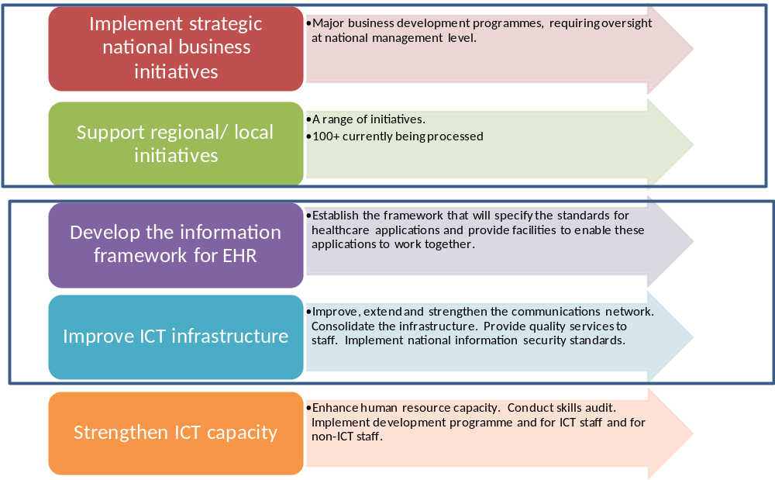

Strategic Goals
We will realise the ICT Vision through attainment of the following strategic goals:

Strategic Goal #1:
ICT will enable integrated, person centric, service delivery.

Strategic Goal #2:
ICT will increase the effectiveness, efficiency and economy of operations within the HSE.

Strategic Goal #3:
ICT will act as a catalyst for change, providing innovative, technical solutions that will transform the business.

This strategy will define the programmes required to achieve these goals.

Translating the Vision into Reality
To achieve the vision, the priority over the lifetime of this strategy will be to ensure that systems are delivered that reflect the needs of the business and provide maximum benefit to patients and clients. Ensuring value for money in all activities will be a fundamental requirement. The ICT directorate will continuously monitor emerging trends and technologies to ensure the most appropriate options are being offered in response to key business requirements.

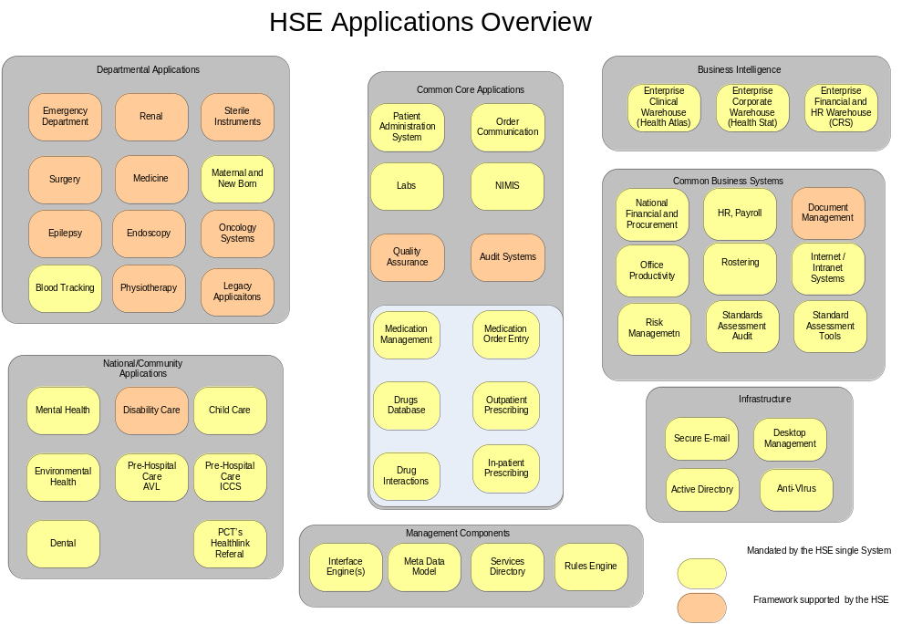

Governance
The ICT Steering Committee will be established and provide overall governance to ensure the strategy is delivered. The committee will include executive level management and clinicians from across the organisation. The committee will be responsible for ensuring ICT priorities constantly reflect those of the overall business. Requests for deployment of all new systems will be managed via the ICT Project Approval Framework Process and subject to sanction under Department of Finance circular 02/11.

Strategic Programmes
ICT infrastructure and applications are substantially as they were when the HSE was formed in 2005. Whilst investments have been made to streamline some aspects of it, reduce costs and increase capacity in certain areas, in the main the solutions available today are still based upon the legacy ICT infrastructure and applications that was deployed during the time of the health boards. Even the email systems, while presenting users with a @hse.ie address are no more than a collection of the previously discrete health board email systems. Whilst this approach has served the health service reasonably well so far by providing continuity of service with minimal additional investment, fundamental deficiencies are now apparent and need to be addressed. The ICT Strategy will address those deficiencies.

Without change, the HSE will find it increasingly difficult to manage the health service as a single entity and almost impossible to implement meaningful ICT solutions that support the patient journey and the integrated model of care. Furthermore, providing national visibility of operational and financial performance data will continue to present a large administrative burden at a time when headcount needs to be reduced.

The main activities required to support the HSE and successful implementation of the ICT strategy have been grouped into the following strategic programmes:

- Rationalisation of ICT Technical Infrastructure

- Rationalisation of Existing/ Legacy applications

- Implementation of Core Hospital Systems

- Integration of Primary Care

- Expansion of Corporate and Operational Support Systems

- ICT support for the National Clinical Care Programmes

- Pre Hospital Emergency Care Systems

- National Child Care Systems

- Public Health Systems

- Quality, Risk & Safety Systems

- National Cancer Control Programme Systems

- Demand Led Schemes (PCRS)

- Community and Continuing Care Systems

- The Electronic Health Record

There is a substantial body of work required to deliver each of these programmes. More detail is provided in chapter 5 of this document.

Whilst not defined as a separate programme, in the context of the Public Sector Reform Agenda – Transforming Public Services, there will be favourable consideration of e-Gov and e-Health initiatives. The health system needs to develop appropriate solutions to play its part in the achievement of ‘joined-up’ government’ as outlined in the New Connections strategy. Over the lifetime of this strategy we will see an increased number of web type solutions being deployed. Internally these will typically be used to provide nimble solutions that enable improved operational performance. Externally, web based solutions will make health services and information much more readily accessible.

Challenges
Successful implementation of the ICT strategy has many dependencies. Failure to manage these dependencies has severely limited the potential of ICT in the past.

The most significant dependencies for ICT are:

- Stakeholder Engagement

- Resourcing

- Effective Governance, Risk and Change management

- Our ability to demonstrate that investment in ICT enabled projects will provide a better return than competing business/service line initiatives.

Provided we can manage these dependencies, the resulting ICT strategy will be successful and:-

- Be enduring over time

- Provide clarity and focus on what needs to be done in the short, medium and long term

- Enable us to validate new (and existing) initiatives for strategic alignment

- Be capable of accommodating change.

Opportunities
Successful delivery of the ICT Strategy will provide confidence in the future and proof that the application of changes in operational processes underpinned by robust ICT solutions can and will make a real difference to the quality of care provided to citizens, and the efficiency by which such care and services are delivered.

Introduction

This document outlines the Information and Communications Technology (ICT) strategy for health and personal social services in Ireland for the period 2011 – 2016.

The strategy is based on the premise that ICT plays a fundamental role and is a central and necessary presence in high performing, best practice health systems. Some considerations from these high performing healthcare systems include:

- At operations level, ICT is established as an embedded factor in the structure and process of patient diagnosis, treatment and care and increasing its relative importance here. It is the prime driver of significant and continuous improvements in efficiency, effectiveness and quality / safety of patient services.

- The application of medical technology in the diagnosis, treatment and care of patients is pervasive and advancing exponentially.

- The utilisation of telecare (monitoring / communications technology) for remote tracking of patients (mainly their compliance with prescribed diagnosis / treatment regimens) and resources is developing rapidly.

- At corporate functions level (Finance, HR etc.), highly developed and integrated ICT systems are established as fundamental business support and assurance requirements.

- Information from operations and corporate ICT systems is now well determined as an essential support to performance management of the healthcare system. Its importance is increasing.

- ICT is consequently central to healthcare strategic, management and operational development, planning and control.

- Systems at unit (e.g. Hospital, GP etc.) level are underpinned / connected through an integrated technical and standards infrastructure.

- Finally, information from health system ICT is critical to production of population health and associated data and informing policy formulation at national level.

Expansive development of ICT within the Irish health system is consequently a necessary strategic, management and operational imperative with substantial improvements in efficiency, effectiveness and quality / safety of patient services as its key focus and driver. This strategy is designed to provide a blueprint for progressing ICT within this framework.
All future ICT initiatives are to be undertaken within the parameters of this strategy.

Future Healthcare System

The purpose, or mission, of the HSE is:

“to enable people to live healthier and more fulfilled lives”

HSE Corporate Plan
The ICT strategy is driven by the overall strategy and objectives of the Health Services Executive (HSE) as expressed in the Corporate Plan and Annual Service Plans. It takes into account key developments such as the introduction of the Integrated Model of Care, the establishment of the Integrated Services Directorate and associated Integrated Services Programme, the establishment of the Quality, Risk and Clinical Care Directorate and associated Clinical Care Programmes.

The strategic objectives for the HSE as reflected in the Corporate Plan are as follows:

Health and Wellbeing: We will invest in preventing illness; supporting, encouraging and empowering people to pursue independent, healthy and fulfilling lifestyles to reduce the likelihood of illness. We will ensure that early diagnosis, treatment and care options are available, if required.

Sustainable Services: We will reconfigure our services to develop sustainable hospital and community services that provide the care people need now, and in the future. By delivering the majority of care in the community, we will enable hospitals to focus on improving accessibility to deliver more efficient acute and planned care.

Achieving Sustainable Services is a major objective for the HSE. We need to continue to work towards a stronger, more integrated, quality driven and safe health service. The development of an integrated health and social care model for Ireland is essential. By moving to an integrated system we can improve the quality of our services in a sustainable way.

Operational Excellence: We will achieve operational excellence using processes and systems that are efficient, easy for the service users to access and understand, evidence based and deliver value for money.

Unlocking Potential: We will actively support and encourage all staff to achieve their full potential and deliver quality care. In partnership, we will recognise and celebrate achievements and encourage staff to work responsibly, manage challenges and take pride in their contribution to the services they provide on behalf of the organisation.

Quality and Safety: We will ensure the quality and safety of our services. By developing a transparent quality and safety culture and adapting our work practices, we will ensure that continuous quality and safety improvement is integral to all that we do.
Trust and Confidence: We will build the public’s trust and confidence in our health services through the provision of timely, well integrated, professional and accessible services. We will make it easier for people to access the right service, in the right place, at the right time.

The Corporate Plan also provides the following list of key health challenges that are currently prioritised for action:

- The integration of services across the service spectrum from disease prevention through primary and community care to hospital care, to allow the service user to be managed at the most appropriate level for their care needs.

- The prevention and management of chronic diseases.

- Cancer prevention and provision of quality assured treatment services.

- Promotion of mental health and provision of support and interventions for those with mental health problems.

- Promotion of patient self care and provision of information for service users.

- Control of health care acquired infections (HCAI).

- Supporting people with disabilities to achieve their full potential, including living as independently as possible.

- Enhancing the quality of life of older persons, supporting them in their homes and communities and, where this is not possible, providing them with access to appropriate residential accommodation.

- Promoting and protecting the health and well being of children and families.

An Integrated Health and Social Care Model
In determining the future of Irish Healthcare arguably the single most significant objective is the successful development and implementation of an integrated health and social care model.

An integrated health and social care model develops services with the service user at the centre and services as close to home as is reasonably possible. Patients / clients in an integrated system are more likely to receive the type and quality of care they need, when they need it, in the most appropriate setting and from the most appropriate health professional. It is based on a way of delivering health and personal social care that enables staff to maximise their skills and the care they provide. It also promotes greater accountability, transparency and value for money.

Implementing an integrated health and social care model will achieve the following:

- A shift towards prevention and better self care rather than a focus on acute care and treatment.

- The right balance between inpatient, day case and community based care.

- Services more accessible locally, centred around the patient, rather than centred around hospitals.

- Improved patient outcomes.

- More efficient use of resources and more transparent.

The introduction of an integrated model of care has significant implications for ICT including expanded use of Electronic Patent Records (EPRs) and the development of National Electronic Health Records (EHRs). Work has already started to develop an Integrated Services Framework (ISF) to define the necessary data models and standards required to facilitate delivery of the EHR.

Environment
The environment in which we operate is dominated by concerns regarding patient safety and public finances. The future budgetary outlook combined with initiatives such as the recent public service agreement are likely to drive significant changes in the health service environment including, but not limited to
- A continued moratorium on the hiring of new staff.
- Reductions in overall staffing levels as result of voluntary redundancy and early retirement schemes.
- Reallocation of staff and resources to areas where they can be used more effectively.

ICT will be required to operate within this environment and to provide innovative solutions that enable the HSE to operate more efficiently. In this way service levels can be maintained using reduced resources.

Organisation
Along with the drive towards an integrated care delivery model there will be an increased emphasis on the development of clinical care programmes. Work in this area is already well progressed with the establishment of the Quality & Clinical Care Directorate and the appointment of national Clinical Directors

A major theme of 2011 national service plan is the start of the implementation of the national clinical programmes. A highly ambitious plan of work has been outlined for 2011 in this regard. The focus will be on standardising care and implementing proven solutions to save lives, prevent complications, significantly reduce waiting lists and save money. While the full benefits of this work will take time to be fully realised, 2011 will be a very important year in embedding many of these solutions within our
clinical services. The areas that will commence implementation include:
- Acute Medicine Programme
- Emergency Medicine Programme
- Elective Surgery Programme
- Diabetes Programme
- Heart Failure Programme
- Stroke Programme
- Epilepsy Programme
- Chronic Obstruction Pulmonary Disease (COPD) Programme, and
- A range of initiatives to address outpatient waiting lists including neurology, dermatology and rheumatology.

A striking example of the potential of these programmes is the plan for stroke care. The establishment of 9 new stroke units and the availability to 24/7 thrombolysis therapy (clot busting treatment) across the country has the potential to improve patient outcomes and to prevent the development of severe disabilities.

Significant organisational changes which reflect environmental shifts, mainly from the Integrated Services programme, are already under way. Within the service provision areas there is a shift from a predominantly pillar (functional) structure to an integrated (service) structure organised around population/ geographical clusters.

The HSE aims to provide people with the type and quality of care they need, when they need it, in the most appropriate setting and from the most appropriate health professional or team of health professionals.

Delivery of services crosses between primary, community and hospitals. Services are being reconfigured to focus on the complete needs of the patient and / or client, while also prioritising effective working relationships across services, providing a more responsive and accountable service. Figure 1 illustrates the HSE service delivery model and where services will be provided in the future.

Within the primary, community and continuing care sector, services will be largely provided in Primary Care Teams. Primary care teams are population based and centred around communities. A primary care team includes a range of professions including for example, general practitioners, practice nurses, public health nurses, Home help, Physiotherapists, Occupational Therapists and other allied health professionals. Primary care teams will be supported by primary care networks that will include a wider range of more specialised services such as speech and language services, psychology services and dental services.

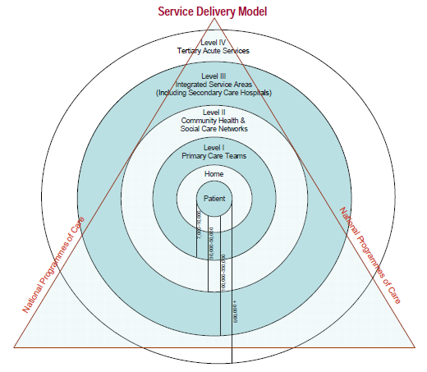

Figure 1: The Integrated Service Delivery Mode

The strategy for mental health services in Ireland, Vision for Change, envisages a further move from institution based services to provision of services in the community. The strategy is to have community based mental health teams that will work closely with the primary care teams in how mental health services are delivered.

There will be a greater development of long-stay community care facilities and increased emphasis on utilising these as step-down from acute hospitals. This will ease the pressure on the acute hospital service but more importantly enable people to get the appropriate care in a more suitable setting that is closer to their home. The Government have now established the ‘Fair Deal’, to ensure that elderly people get fair access to home and residential care. There are plans to increase the number of community nursing units, home care packages and private nursing home beds to meet this need.

The ‘Acute Medicine Programme’ is a clinician-led initiative between the Royal College of Physicians of Ireland (RCPI), the Irish Association of Directors of Nursing and Midwifery (IADNAM), the Therapy Professions Committee (TPC), the Irish College of General Practitioners (ICGP) and the Quality and Clinical Care Directorate (QCCD), HSE. The programme recognises the essential role of large and small hospitals, general practitioners (GPs) and community services. It provides a framework for the delivery of acute medical services which seeks to substantially improve patient care. The report of the National Acute Medicine Programme published in 2010, recommends four generic hospital models/ types. The purpose of these models is to provide a clear delineation of hospital services based upon the safe provision of patient care within the constraints of available facilities, staff, resources and local factors. The level of service that can be safely provided in any hospital will determine which model applies. The report states that there will be a named physician with responsibility for patients on all aspects of their pathway. It is recognised that streaming of patients between hospitals for some medical conditions is already in existence and these practices should continue where they are operating safely and effectively and be incorporated into the acute medicine programme locally.

As hospital services are re-configured there will be corresponding requirements to change the way in which pre-hospital emergency care services are provided with:
- The requirement for centralisation of national emergency response capability.
- A significant expansion of advanced emergency technician numbers and their capacity to respond / communicate with Regional / Academic Hospital centres.

Pre-hospital emergency care will also work more closely with primary care and in particular with the out of hour’s doctor service.

Delivery
The following are some of the key changes in how services will be delivered:

- Patient transition through the system to be fully integrated / seamless
- Shift from episode-of-care approach for patient to holistic lifetime care perspective
- Managed transition of patients through the primary, community and continuing care services and between these and the hospital / programme sectors
- Central dependence on pre- hospital care and substantially enhanced roles for Advanced Nurse Practitioners, therapies etc.
- Workforce appointments shared between acute / non-acute sectors with individual clinicians (mainly nurses, therapists, technical etc.) following the patient from one location / jurisdiction to another rather than handing-over
- Hospital based acute diagnosis, treatment and care to be distributed between Academic / Regional and local centres in accordance with casemix severity with Consultants performing / delivering treatment / care in multiple settings accordingly
- Shift from institution based care in services, such as mental health, to community based care settings.

For the patient/client access to services will be achieved via a health professional who has responsibility for ensuring appropriate access to healthcare service in both acute and non-acute settings.

Funding and Resourcing
As a pre cursor to the introduction of Universal Health Insurance, there is a requirement for ‘funding to follow the patient’. Funding will therefore move away from block funding for hospitals and towards being provided on the basis of outputs with increased attention to performance management systems. Focus will continue on ensuring that the HSE delivers on its annual service plan, within the specified allocation. There will be increased pressure on generating value for money and efficiencies in order that the HSE meets its financial obligations under vote accounting and to support increased developments within our healthcare system. It is anticipated that there will be further development of incentive based systems, such as the case mix system currently in acute hospitals, to drive improvements in service.

Human resource policy will continue to be set centrally. There will be continued emphasis on HR workforce planning, management and control to ensure the HSE has the right types and numbers of staff, improved work practices, and that the HSE operates within its employment ceiling provided for by government.

Implications for ICT strategy
As stated previously, the ICT strategy is driven by and supports the organisation’s business strategy as defined by the HSE Corporate Plan and Annual Service Plan.

The strategy must take into account the likely future state of health service mindful of the environment, the organisation, the manner in which services will be delivered, the desire to implement an integrated model of care along with the funding and resources available.

The implications for the ICT Strategy are summarised as follows:

- Solutions are required that can support the integration of healthcare services and the implementation of the Integrated Model for Health and Social Care.

Essentially, information related to the patient/ client must be capable of being accessed and updated as the patient ‘journeys’ through the health and social care ‘system’.

This implies a need for greater integration and interoperability between systems and a method to uniquely identify users of the health care system. It also implies that:

  - Information will have to be patient/ client focussed (rather than healthcare provider/ site specific)
  - Information on the patient must be capable of following that patient through the system
  - It must be possible for health professionals to access all pertinent information on the patient at point of consultation, diagnosis, treatment and / or care
  - It must be possible for the relevant health professionals to add to the patient record at point of consultation, diagnosis, treatment and / or care
  - It must be possible for health professionals to communicate and receive information, requests for service, bookings etc. in respect of patients to / from third party sources
  - It must be possible for patients to access information on their personal health and schedule appointments
  - It must be possible for pre-hospital care professionals to contact and transmit patient physiological information from remote locations wirelessly
  - It must be possible to access and merge patient, financial and HR information for planning, control, decision making, performance, quality/safety/RM etc. purposes
  - It must be possible to consolidate and analyse data for population health planning and for corporate and service planning
  - It must be possible to technically transmit information across the entire system
  - It must be possible to assemble/merge data from multiple locations and systems
  - It must be possible to assemble data on a specific patient from multiple locations/systems, each of which identifies the patient by multiple reference criteria

- There will continue to be a need to deploy clinical and social care support systems as identified by the Corporate Plan and Annual Service Plans. Where there are multiple, competing demands on finite resources, the ICT Steering Committee prioritise the allocation of resources based on the relative merits of each business case presented.

- There will be an increased focus on systems that support the prevention and management of Chronic Diseases and other areas such as A&E and Outpatient Departments, as prioritised by the Quality and Clinical Care Directorate. Chronic Disease absorb a very significant portion of the overall health service budget and are therefore an obvious area to target critical resources.

- There are requirements to expand our capabilities in the area of standards based Performance Management Systems

- There is an urgent need to implement a single, enterprise wide, National Financial and Procurement System (NFPS) to replace the legacy finance systems that were put in place during the time of the health boards. The implications ‘funding to follow the patient’ as a pre cursor to the introduction of Universal Health Insurance and indeed the introduction of insurance companies will need to be carefully considered as part of the NFPS project.

- There will be a significant dependency on ICT to deliver greater value for money from the current level of spending on the health service. Given the economic outlook, there will be increased pressure to deliver ICT solutions that free up service line resources and reduce administrative costs. In line with the e-Government 2010 Strategy and wider Government policy, we will be required to make better use of technology to reduce process costs; develop services to the public in new ways; provide 24/7 services where possible and utilise best practice in ICT procurement to achieve economies of scale. There will be requirements to deliver technology, systems and innovative solutions that leverage the potential savings afforded by recent public service agreement.

Lessons learned from previous ICT strategies in Ireland
The following ICT related healthcare strategies were developed in Ireland over the past decade and are considered relevant in the context of defining the future role and strategy for ICT.

- Dublin Academic Teaching Hospitals (DATHs) Convergence Strategy (2003)
- National Health Information Strategy (2004)
- HEBE ICT Strategy (2004)
- PCCC ICT Strategy (2005)

The Dublin Academic Teaching Hospitals Convergence Strategy (2003) reviewed the existing ICT services within the five large voluntary hospitals that constitute the DATHs and made recommendations on the establishment of an ICT service delivery model and organisational infrastructure to provide for the unified management and control of the DATHs’ combined ICT resources.

The National Health Information Strategy was published by the Department of Health in 2004. The underlying principles of the strategy were to:-
- Safeguard the privacy and confidentiality of personal health information
- Ensure that health information systems are efficient and effective
- Promote the optimal use of health information
- Ensure the high quality of health information.

The strategy proposed 27 actions. The first seven concerned the Health Information and Quality Authority, which has since been established. Some of the other actions stipulated that health information would be geo-coded, a health information portal would be developed, an electronic health record would be implemented on a phased basis and a system for unique identification within the health sector using the personal public services number (PPSN) would be introduced. This action plan is currently being reviewed by the Health Information Inter Agency Group.

The HEBE ICT strategy was developed in 2004. This was a very comprehensive document, developed jointly by the health boards ahead of the formal establishment of the HSE.

Central to the strategy was the need for a standards based, enterprise wide, systems policy i.e. a common approach to satisfy identified needs for the entire health system. The document set out a vision as to what this would mean – in summary, stating it would put the person at the centre of care delivery and support an integrated health enterprise.

The PCCC ICT Strategy was finalised in June 2005. This strategy was commissioned by the Department of Health and involved consultation with a wide range of stakeholders within PCCC. The strategy recognised the need for access to patient health records throughout the continuum of care but recognised the challenge of providing this via a national Electronic Health Record. It therefore suggested a two phased approach with phase 1 delivering some shorter term, more readily achievable ICT deliverables that could improve patient and client facing services delivered within the PCCC environment.

Some key themes to emerge from all these strategies are:-

- The need to adopt an enterprise-wide approach to healthcare ICT

- The desirability of having a two-phase approach to the development of ICT in those areas that are under-developed in terms of current provision of ICT
  - Phase 1 to put basic building blocks in place
  - Phase 2 to deliver integrated solutions

- The need to develop a formal Electronic Patient Record and Unique Health Identifier.

- The need for better utilisation of scarce ICT skills

Viewed from today’s perspective all of the above strategies appear to be too ambitious. This said, in many instances, initiatives set out in the above strategies are still deserving of support today. Evidence would suggest that there has been very limited progress in the implementation of recommendations from these prior strategies.

Vision for ICT

Vision Statement
‘To deliver sustainable improvements in health and social care for patients and clients, via the deployment of cost effective, standards based, secure technology and applications, that provide access to meaningful, timely, and relevant information, when and where it is required.’

Principles
ICT will support and enable the provision of quality healthcare and will:

- Be patient/client centric

- Support clinical practice and the integration of primary and secondary care

- Support quality and safety of care and transparency in outcomes

- Support the development and implementation of care pathways, standards, clinical engagement and leadership

- Provide access to information when and where required

- Provide information that is meaningful, timely, and relevant

- Support greater efficiency and effectiveness in the provision of healthcare

- Be consistent with the objectives of the organisation

- Support e-Government, e-Europe and e-business initiatives

- Be based on information and technology standards

- Ensure the security and integrity of data and systems

In summary, our focus must be on information that is patient centric, integrated and accessible.

Strategic Goals
We will realise the ICT Vision through attainment of the following strategic goals:

Strategic Goal #1:
ICT will enable integrated, person centric, service delivery.

Strategic Goal #2:
ICT will increase the effectiveness, efficiency and economy of operations within the HSE.

Strategic Goal #3:
ICT will act as a catalyst for change, providing innovative, technical solutions that will transform the business.

This strategy will define the programmes required to achieve these goals.

ICT Objectives
To achieve our goals we must set clear objectives. ICT objectives must be directly aligned to those of the organisation. HSE objectives are most succinctly defined by the Integrated Services Programme.

There are 13 individual programmes that make up overall Integrated Services Programme. There are six core ‘Service Transformation’ programmes and a further seven supporting ’Enabling Infrastructure & Capabilities’ programmes.

 | Service Transformation Programme Objective | Corresponding ICT Objectives
1 | Develop integrated services across all stages of the care journey. | Identify and implement ICT enabled Applications, Services and Infrastructure Components that directly facilitate greater integration of services across all stages of the care journey.  Establish the Integrated Services Framework project as the first step towards development of a national Electronic Health Record (EHR).  Identify & implement ICT enabled tools and services, that support collaborative working and sharing of data and information to facilitate the integration of services.
2 | Configure Primary, Community and Continuing Care services to deliver optimal and cost effective results. | Implement ICT Infrastructure into all Primary Care Team sites to establish a minimum level of capability in all of these sites that will support a common set of applications and services.  Identify and implement ICT Enabled Applications and Services that support the care groups responsible for delivering primary, community and continuing care services.  Ensure all such systems conform to common standards, as appropriate, such that they support the requirement for integration of service.  Enable secure electronic referrals for Primary Care Teams and between GPs and Acute Hospitals
3 | Configure hospital services to deliver optimal and cost effective results. | Ensure that all hospitals are up to a common level of capability with regard to their key ICT and ICT enabled systems - commensurate with their scale and role within the organisation.  Implement the ‘Core Applications’ identified by this strategy in all HSE hospitals. Establish national contracts and/or frameworks to enable hospitals to implement these systems in the most cost effective and timely manner.  Ensure regional and local initiatives are aligned nationally and support these initiatives within in the context of finite available resources.  Ensure all such systems conform to common standards, as appropriate, such that they support the requirement for integration of service.
4 | Implement a model for the prevention and management of chronic illness. | Engage with the Quality & Clinical Directorate to identify and implement ICT enabled applications that support the prevention and treatment of patients with Chronic Diseases.  Support the Quality & Clinical Directorate in the implementation of their prioritised list of clinical programmes.  Ensure all systems conform to common standards, as appropriate, such that they support the requirement for integration of service.
5 | Implement standards based performance measurement and management throughout the HSE. | Identify and implement ICT Enabled Applications that support performance measurement.  Such systems will at a minimum include HealthStat but may also include other key service performance management systems.  Leverage existing applications and systems to extract key performance data.
6 | Ensure all staff engage in transforming health and social care in Ireland. | Identify and implement ICT Enabled Applications and Systems that support greater efficiency and effectiveness in operations and greater collaboration between staff.  Propose, support and implement initiatives derived from current Government/ HSE/ Union agreements.  This is an area where ICT can contribute significantly by using readily available technology and communications systems that support networking and co-operation on local, regional and national initiatives.

 | Enabling Infrastructure & Capabilities | Corresponding ICT Objectives
1 | Finance: Budget allocation model and finance systems. | Implement a single National Finance & Procurement System (NFPS)
2 | Shared Services strategy and implementation. | Identify and pursue shared service initiatives within the ICT Directorate and it operations that will bring greater efficiency and benefits to the organisation.
3 | Human resource strategy and delivery. | Identify and implement ICT Enabled Applications that support long, medium and short term goals of the HR function within the HSE.  Extend the footprint of the current SAP HR system to cover the remaining (2) former health boards. Streamline the manner in which such systems feed payroll.  Support business driven initiatives to deploy personnel performance management systems, rostering systems, attendance systems etc.
4 | Information and Communications Technology (ICT). | Establish a single national communications network that will support all health service staff, allowing any authorised person to access approved computer facilities from any location.  Establish one email service for all authorised healthcare users  Consolidate application and infrastructure services, server and data centre infrastructure into a small number of centres.  Implement a standard set of server and network device hardware.  Implement national information security policies and procedures  Implement a converged voice and data network that will carry data, fixed and mobile voice traffic.  Ensure all major Infrastructure acquisitions are based on framework agreements  Develop a technical architecture that provides optimal value for money in on-going operations.  Apply the ICT technical principles as defined by CMOD and described in section 6.7.1
5 | Facilities / Estates strategy and implementation. | Identify and implement ICT Enabled Applications that support HSE Estates.
6 | Board, Corporate stakeholder and relationship management. | There will be one ICT Steering Committee responsible for engaging with the business at the most senior level and making priority decisions in relation to ICT based on the availability of resources.  There will be governance models in place for all ICT enabled projects and initiatives and will be appropriate for the level of stakeholder engagement and relationship management required.
7 | Procurement. | Implement a single National Finance & Procurement System (NFPS)  Establish standard ICT contracts in lieu of the more generic (non ICT) ones that are used today.

Critical Dependencies
Successful implementation of the ICT strategy has many dependencies. Failure to manage these dependencies has severely limited the potential of ICT in the past.

The most significant dependencies for ICT are:
- Stakeholder Engagement
- Resourcing
- Effective Governance, Risk and Change management
- Our ability to demonstrate that investment in ICT enabled projects will provide a better return than competing business/service line initiatives.

Provided we can manage these dependencies, the resulting ICT strategy will be successful and:-

- Enduring over time
- Provide clarity and focus on what needs to be done in the short, medium and long term
- Enable us to validate new initiatives (and current activities) for strategic alignment
- Be capable of accommodating change.

Translating the Vision into Reality

The purpose of this chapter is to describe the areas that ICT will focus on over the lifetime of the strategy. The ICT strategy is directly driven by the priorities of the HSE organisation as expressed in HSE Corporate Plan, Annual Service Plans and other key strategic and operational plans.

The ICT strategy will be the primary reference for emerging projects and will be used to validate whether such initiatives should be pursued, deferred or indeed rejected.

Whilst this chapter may not define every project that will be pursued it will define our priorities at a level that is unambiguous, appropriate and that can facilitate robust planning.

The main activities required to support the HSE and successful implementation of the ICT strategy have been grouped into the following strategic programmes:

Rationalisation of ICT Technical Infrastructure
The primary strategic objective for the ICT Infrastructure and Operations team is to implement a single HSE Enterprise Infrastructure.

This will require a rationalisation of the existing ICT technical infrastructure.

The technical architecture will be constructed to provide consistent, reliable support for the computer system applications, provide appropriate access to all healthcare system users and enable the applications and computer facilities to inter-operate.

The ICT directorate will closely monitor emerging trends and consider the implications of technologies such as ‘Private Clouds’ as potential solutions for the delivery of specific services and applications.

Technical Principles
The HSE will adopt the following technical principles as defined by the Department of Finance, Centre for Management, Organisation and Development (CMOD).

- One set of technology plans based on strategic objectives for the HSE and its business plans
- One technical architecture
- One network architecture
- All systems to fit within the chosen (and Finance approved) technical, information and applications architectures
- One addressing and directory infrastructure
- One single sign-on structure
- Centrally managed servers and centrally managed desktops
- No unnecessary middleware - whether hardware or software
- Firewalls at the edge only
- One Internet access regime
- Maximising shared platforms/services within the HSE, across the public service and with the private sector as appropriate
- One set of facilities for mail and mail content checking
- One set of computer usage guidelines
- One set of security guidelines
- One set of business continuity and disaster recovery processes in place
- One licence library/repository
- One ICT asset management system
- One ICT service management system
- One project management methodology based on current best practices.

Technical Architecture
Development of the ICT technical architecture will be guided by the ‘HSE National ICT Infrastructure and Operations Architecture Document’. Whilst this is a live document which is subject to revision, the key strategic messages are as follows:

- The current technical architecture will be streamlined to reflect a single national organisation, facilitate the integration of services and the management of those services at a local, regional and national level. There will be consistency in how those services are offered and frameworks will be established to ensure maximum value for money.

- The technical solutions deployed will actively support collaborative working at a clinical and administrative level. The architecture will simplify access to systems and data irrespective of location, subject to a consistent set of access rules. Infrastructure to support PC based audio/ video conferencing, white-boarding and national shared data drives/ repositories will be established. Access to such services will be universally available.

- We will prioritise the continued elimination of fragmented infrastructure that is a legacy of the individual health boards.

- We will flatten the communications infrastructure via the deployment of the National Health Network (NHN 1) and build resilience and additional capability via NHN2.

- We will implement a single IP addressing scheme nationally and so remove the technical boundaries that defined the legacy health boards. Since the establishment of the HSE this has prevented or at the very least made it cumbersome for systems located within one health board from being legitimately accessed by staff from another legacy board.

- We will develop standard design templates for large, medium and small sites. The templates will take into account the type and complexity of the site, the activities concerned and other operational considerations. Once developed, all sites will be categorised by type. All subsequent requests for investment in technical infrastructure by sites will be checked for alignment with the relevant template. This approach will ensure consistency in the resulting infrastructure, preventing over (and under) investment on a per site basis and ultimately resulting in a planned and predictable levels of capability on each site. Sites of similar scale and type will, in the future, have similar technical infrastructure capacity, resilience, disaster capabilities etc. irrespective of location or other compounding factors.

- There will be standard solutions and applications for all key infrastructure components – with frameworks in place to support same.

- There will be common client devices, desktop applications, anti virus software and content filtering system nationally.

- There will be a common method of accessing HSE networks remotely with consistent rules governing the use of this service.

- There will be a single, national service management model and national helpdesk.

- In pursuit of greater levels of integration between clinicians and care providers in the primary care arena and elsewhere in the service, we will consider the potential a single national encrypted email service for the entire health service.

- We will promote the use of shared services and the national data centre to leverage value for the organisation.

- We will promote virtualisation as a cost effective way to provide new services and support legacy applications.

- We will promote cost effective e-business initiatives by delivering a technical architecture that provides a scalable, fast, resilient and secure environment for intranet and internet applications and services.

In summary, there will be
- One physical network with appropriate resilience. This will be a centrally managed HSE network and communications infrastructure with access appropriate to the needs of particular site-types, such as, acute hospitals, administrative headquarters, local health offices and primary care teams.
- The physical network will support all health service staff, allowing any authorised person to access approved computer facilities from any location.
- One email service for all authorised healthcare users
- A common directory service encompassing all HSE staff and those staff in HSE funded organisations.
- Consolidation of application and infrastructure services, server and data centre infrastructure into a small number of centres.
- A standard set of server and network device hardware
- National information security policies and procedures
- A converged voice and data network that will carry data, fixed and mobile voice traffic.
- Infrastructure acquisition based on framework agreements.

Rationalisation of existing/ legacy applications
There is a pressing need to rationalise the ever growing number of legacy ICT applications, whose number now exceeds 1000 and becomes potentially unmanageable. Options for rationalisation include retirement of applications, upgrading, or migrating to a virtualised environment. The ICT directorate intend pursuing a rationalisation programme over the lifetime of this strategy to try and free up limited applications support resources to support the new applications delivered as part of the strategy. ICT Applications Services:

ICT Application Services

The goal of the Applications Services group within the ICT directorate is to create a set of services to ensure the best support is provided to new and existing Applications Systems in the HSE. These services will be applied to the existing landscape of Applications systems (supplied by about two hundred and fifty vendors) and to the range of ICT approved projects and initiatives.

Support for the existing landscape is historically provided singularly or by a combination of ICT, User groups, Vendors, super users and in some cases may not be provided for at all. A programme of work has been identified to examine and develop Applications Services as follows:

- To perform a detailed review of the existing Applications Landscape and to maintain an up to date list of these assets
- To examine risks associated with this asset base and report regularly to ICT management and business management
- To consolidate the asset base where appropriate
- To improve Vendor management of the asset base
- To improve upgrades and enhancements management of the asset base
- To improve support and support structures for new ICT related projects by introducing support planning earlier into the ICT project life cycle
- To improve support and support structures for the existing asset base following on from the detailed Applications review

Obviously, with the large number of applications systems, a phased approach will be taken to this work where priority will be give to the larger and more critical application systems. Expanding this work to HSE funded agencies may also be considered in the lifespan of this strategy. A critical success factor to all of the work outlined above will be engagement from the business community who rely on these systems to perform their functions within the HSE.

At a more detailed level, Applications Services will be looking to implement, improve or expand other services such as:

Internal ICT applications development capability for small to medium system implementations
Report on applications security standards, access management, user management
Advise and improve on systems change control, version control, product road map reviews
Assist in the improvement of SLA’s, support and maintenance contracts, licensing/Escrow and application environment standards (Test, QA, live systems)
Explore application usage, functionality exploitation, application housekeeping and assist developing expert groups and user groups

Implementation of Core hospital systems
Whilst there continues to be an underlying requirement to enhance the number, type, capability and capacity of clinical systems, the priority over the lifetime of this strategy will be to ensure that all HSE hospital sites have at least the following core systems deployed:

- Patient Administration System (PAS) - for Admissions, Discharges, Transfers.

- Order Communications and Results Reporting

- PACS/ NIMIS

- Laboratory Systems

- Medication Management

Deployment of these systems will establish key stepping stones towards the delivery of Summary Care Records and ultimately national Electronic Health Records.

Systems will not be replaced on a ‘rip and replace’ type basis. Systems that are already fit for purpose will only be replaced when there is a natural break in the product lifecycle or where the cost of integrating such systems with other key national initiatives or systems is prohibitive.

Integration of Primary Care
The primary care strategy, “A New Direction”, set out a strategy for Primary Care, some of the key principles being that the core unit of service delivery would be the inter-disciplinary team and that Primary Care Networks would be developed to support the Primary Care Teams. ICT will support the implementation of the strategy and provide the analysis skills necessary to help management define ICT requirements.
An immediate priority is to support the continued rollout of primary care teams. This will involve the continued deployment of ICT technical infrastructure to primary care team sites and the identification and deployment of suitable applications.

To support the integration of primary care, GPs will be encouraged to adopt practice management systems. The HSE will provide funding to the national GP IT group to maintain an accreditation process to help ensure that these systems operate to an acceptable quality standard and they are capable of interacting with other systems and messaging services. The HSE will endeavour to conduct business transactions with GPs in an electronic form so that information may be extracted directly from practice management systems and information going to the practice may be directly inserted into the practice system. Accordingly, the HSE will continue to develop the National Messaging System ‘Healthlink’. Indeed Healthlink will be the national messaging solution for communicating between the primary and secondary care domains going forward and where ICT capital investment will be directed in the future.

The deployment of GP practice management systems, combined with Healthlink, will support the rollout of streamlined processes that can significantly improve the speed at which care is provided. Such processes will include:-
- Laboratory test requests/ test results
- Radiology test requests/ test results
- Electronic referrals
- Electronic discharges reports
- Mother and child scheme returns
- Immunisation messages

There will be improved patient journeys by deploying a simple, single secure email solution to all care providers irrespective of location. The resulting solution will provide a method for GP’s, primary care team members and hospital based clinicians to communicate and collaborate on patient care and clinical matters.

Over the lifetime of this strategy consideration will be given to the following priorities as identified by the GP IT Group:
- Substantial ICT investment in health care to bring GPs onto the National Health Network
- Provision of secure clinical email and health care messaging to all GPs nationally
- Expansion of the range of health care messages available
- Facilitating electronic communications between GPs, hospitals and within primary care teams.
- Electronic support for structured care of chronic diseases and preventative care.

In summary, the priorities are messaging, secure email, network and chronic disease. At a minimum an agreed range of structured messages from hospitals should be available to all GPs nationwide.

There will be dedicated standardised systems to support the work of public health nurses, social workers and other primary care professionals across the country. These systems will support the work of the healthcare professionals by providing some specific functionality and they will present views of data from other dedicated applications.

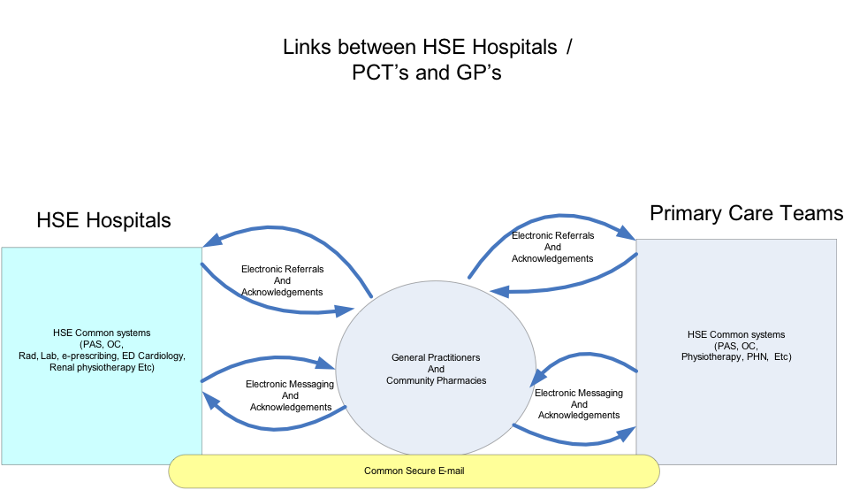

Expansion of Corporate and Operational Support Systems
Our strategic objectives in this area are to:

- Deliver innovative “Back Office” solutions to Corporate administrative and support services

- Provide decision makers with timely, accurate & relevant Management, Executive and Decision Support information - in a meaningful format

- Streamline business operations using ERP, Workflow and eServices solutions

Enterprise Resource Planning (ERP) Systems
There will be a set of financial applications across the health sector to provide a consistent set of functions to support the operational needs of the service and to provide information for monitoring and managing the service and for strategic planning. The financial applications will be based on a standard set of codes reflecting the needs of the sector and on a standard set of business processes. The applications will support a common approach to procurement, invoicing, payment, budgeting, asset management and the full range of financial activities. At the core of the financial application set will be one major application maintained centrally and deployed across the country for the core HSE. Where some voluntary organisations use other financial application software, they will interact with the central system by way of agreed protocols.

Similarly, for human resource management, there will be a set of application software to support the needs of the service. The human resource applications will be integrated with payroll applications and will support consistent operation of human resources policy. These applications will support operational requirements such as staff scheduling, management requirements such as headcount control and strategic requirements such as manpower planning.

Support for Corporate Planning and the Business Intelligence Unit
The HSE has introduced performance management systems that provide methods to measure and compare hospital performance. Over the lifetime of this strategy these systems will be migrated to more sustainable HSE infrastructure platforms.

Performance management applications will be developed to support operations within each of the HSE regional operational areas. Such systems will be developed to facilitate managing performance by objectives.

Non clinical Business Intelligence systems will continue to be developed to assist the HSE corporate function is extracting greater value from investments in the health service. Such systems will include decision support, data warehousing and reporting capabilities, some of which are already in use within the health sector.

Business Process Reengineering, e-Business and e-Government
Beyond ERP applications, and systems to support corporate planning and the business intelligence unit, the ICT Directorate receive a significant number of requests for small or medium scale, non clinical applications to support the running of the service. These are classified as operational support type systems.

Over the past two years we have developed the technical infrastructure and some in house development capability to produce solutions to these business requirements via e-Business and e-Gov channels using web based solutions. Over the lifetime of this strategy we will expand this capability, leveraging the market as necessary, and work closely with business process re-engineering (BPR) teams to deliver solutions for approved projects via this route. The resulting products will be, fast, flexible, user friendly and bring about significant savings when deployed in conjunction with streamlined business and operational processes.

There will also be solutions deployed to improve communications and collaboration, which will make a real difference and be of particular benefit to those working in different geographical areas.

ICT support for the National Clinical Care Programmes
The national clinical care programmes, led by clinical directors and implemented by the integrated services directorate have already been identified and prioritised. They include acute medicine, emergency medicine, elective surgery, diabetes, heart failure, stroke, epilepsy, COPD and the reduction of outpatient waiting lists. Successful delivery of these programmes has the potential to significantly improve patient outcomes and consequently is a high priority for the organisation. The extent to which ICT and related systems will be required has not yet been established. However, priority will be given to applications and systems that derive the greatest benefit from the application of ICT, improve quality of care, provide increased efficiencies and facilitate the implementation of the integrated health and social care model.

It has not yet been determined whether deployment of ‘vertical systems’ is the best way to support the chronic disease programmes. A preferred approach may be to establish an electronic health care record for all patients being cared for, with specific datasets, views and assessments for individual diseases such as diabetes or stroke etc… Decisions regarding the approach must be finalised as part of this programme of work.

Requests for deployment of all other clinical systems (clinical systems other than those determined by the national clinical care programmes) for acute and non acute hospitals will be managed via the ICT Project Approval Framework Process. The ICT Steering Committee will provide overall governance to ensure that ICT priorities constantly reflect those of the overall business.

For the purposes of this strategy ICT will adopt the following approach with regard to selection and deployment of such systems:

- Hospitals that are designated as the national lead site for the treatment of particular illnesses or conditions will drive requirements for the selection and deployment of related ICT systems.
- If patients receive the bulk of their treatment in the designated lead site but receive support/ follow up care in other hospitals it will be the responsibility of the lead hospital to co-ordinate the system requirements for the core as well as the ‘supporting’ hospital/s. In some cases this will result in a single national system with role based access for clinicians based on the lead hospital as well as the support site. In other cases it may be more appropriate for a simpler but complementary system to be deployed in the ‘support’ hospital with appropriate interfaces between the two. The lead hospital will be required to make such decisions and to secure buy in from the hospitals providing support/ complementary treatment and care. The lead hospital will be the single interface to ICT with regard to overall system requirements.
- Where there is no single national lead site for the treatment of particular illnesses or conditions, the ICT project framework approval process will be used to determine the scope for application of a particular system in multiple hospitals. Where such systems can and should be adopted elsewhere, the HSE will tender for single national systems. If this is not practical a framework tender process will short list approved systems, making it easy for subsequent hospitals to leverage national purchasing power, benefit from short lead times and the flexibility associated with being able to select from a group of short listed products.

Pre Hospital Emergency Care Systems
The HSE is currently engaged in a significant reconfiguration programme which will impact how and where hospital services will be provided in the future. The changes are defined and implemented as part of the HSE Integrated Services Programme and have significant implications, indeed dependencies upon, how and where pre hospital emergency care services are delivered. Over the lifetime of this strategy there will be considerable investment in ICT to deliver the single national emergency services communications and dispatch systems. Work in this area is already well underway with the planned introduction of the new TETRA digital radio system, Integrated Call management System (ICCS) and Computer Aided Dispatch (CAD) systems.

Such systems will enable the ambulance service to communicate easier across all regions, provide a more consistent service and deliver the service enhancements required to complement the ongoing reconfiguration of hospital services.

National Child Care Systems
In support of Children First ‘national guidelines for the protection and welfare of children’ the Children and family Services Directorate within the HSE are pursuing a project to deliver the National Child Care Information System (NCCIS). The project is currently going through the public sector Peer Review process.

The purpose of the project is to provide all HSE Social Work/Child Care departments with an easy to use technology solution to record the case history of every child who is the subject of a child welfare and/or protection referral to one of the HSE Social Work Departments from contact and through referral, Initial Assessment and Further Assessment.

The proposed solution will facilitate Social Work recording at an operational/clinical level. Management information can then be derived from the operational system.

The standardisation of business processes and deployment of the ICT system will be managed in three phases.

- Phase 1 - Referral, Initial & Further Assessment – processes are already standardised.

- Phase 2 – Child Protection Business processes

- Phase 3 – Family Support, Family Welfare Conference & Children in Care Processes

Public Health Systems
There will be improved systems for Public Health. We will deliver a single national environmental health information system and a single national system for immunisation programmes along with systems to support the HPV vaccination programme and disease management. There will be continued development of the existing disease surveillance system and continued investment and expansion of the ‘Health Intelligence System’.

Quality, Risk & Safety Systems
Delivery of quality, risk and safety systems including clinical audit systems, corporate risk register/s, and various assessment systems will pursued over the lifetime of this strategy.

National Cancer Control Programme Systems
The National Cancer Control Programme (NCCP) will require implementation and integration of radiation oncology systems, evaluation and implementation of medical oncology clinical systems, a drug data mart and chemotherapy order entry, with linkage to laboratory results and drug interactions.

Systems will be required to support collaboration with the demand-lead schemes for drugs and integration of drug registration and drug data capture. There will be a requirement for integration of Tumour Registry data and clinical and quality data sets.

Systems will also be required to support clinical audit functionality for all cancer programmes (eg surgery, medical oncology, radiation oncology, diagnostic and community services).

Current work to deliver electronic referrals for specific cancers will be expanded.

Demand Led Schemes (PCRS)
For Community (demand led) Schemes, there will be continued development of the systems in place to support administration of medical cards, long term illness, the HiTec drugs programme, GP cards, drugs pharmacy refunds and other national schemes managed by the primary care reimbursement scheme (PCRS) team.

It is imperative to maintain investment in strong ICT systems and support for PCRS because:-
- of amount of public funding involved
- the fact it is a 24 x 7 x 365 operation
- it provides a service directly to the public
- it provides a service directly to GPs, pharmacists and other health care providers
- it must meet aggressive cost saving targets set out for coming years to reduce reimbursement costs and
- it must have systems that are nimble enough to be able to leverage opportunities to reduce reimbursement costs as and when they arise

Community and Continuing Care Systems
To facilitate more consistency in the allocations of resources for older people, a pilot to measure the effectiveness of Standard Assessment Tools (SAT) will be implemented. The outcome of this pilot will determine whether such tools (and supporting processes) will be deployed nationally.

There will be appropriate systems for the long-stay institutions and for the services providing care in the Mental Health and Disability sectors, providing each of these with an electronic medical record for each individual.

ICT requirements for services provided by those responsible for Social Inclusion are not yet agreed but their overall requirement to improve referral pathways between specialist addiction/ homeless/traveller services to mental health and primary care services will benefit from the integration services programme.

The current service plan identifies a need for minimum data set to be established for use by those involved in Palliative Care. ICT will support this initiative.

The Electronic Health Record
To support the overarching objectives of the HSE ‘to develop integrated services across all stages of the care journey’ and to ‘support delivery of the integrated health and social care model’, the HSE will also pursue the implementation of a National Electronic Health Record (EHR).

Successful delivery of a national EHR will provide:
- Improved patient/ client care coordination across the entire health service
- Improved quality of care and outcomes
- Secure privacy and security of information
- Improved operational excellence
- Reduced cost of care delivery

It is internationally accepted that the implementation of an EHR is a long term (and in many cases elusive) goal. The US based Healthcare Information and Management Systems Society (HIMMS) has developed an adoption model for the implementation of EHR’s. The model defines seven levels of maturity. The following slide describes what constitutes each level and the maturity level within the US in 2007 and 2008.

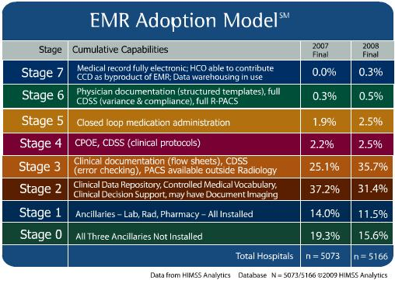

The objective for the HSE is to position Ireland at level 3 of the adoption model by the end of the term covered by this strategy. Deployment of the core applications identified herein is the first step on that journey. Attainment of level 3 would result in clinical data, held in digital form, would be widely available for the creation of summary care records, discharge records and for meaningful and efficient digital interaction between primary care and acute hospital domains. Level 3 is also an essential building block to deliver a national electronic health record.

A comprehensive EHR solution can make patient /client data available to authorised clinicians when and where it is required. To make this possible there are requirements for specific standards, data models and rules governing how various systems will interoperate.

Whilst establishment of the national Electronic Health Record (EHR) is a long term objective for all health care organisations around the world. Over the lifetime of this strategy we intend to put in place many of the building blocks to facilitate the ultimate delivery of the EHR. We will do this by deploying the ‘Core’ hospitals systems and pursuing the Integrated Services Framework (ISF) project.

The purpose of the ISF project is to facilitate the development of standards, integration of health systems and ultimately development of the Summary Care Record and (complete) Electronic Health Records.

The framework will shape the manner in which we reach level 3 of the EHR adoption model. The framework will also define the Common Service Applications and corresponding services required to provide an integrated view across the healthcare spectrum. These services will include, for example, a national client index, health provider index, drug index and location index.
Working closely with the Clinical Directorate, ICT will also examine the potential for development of electronic Summary Care Records (SCRs) as a logical stepping stone towards complete EHRs. We will implement such records by leveraging functionality offered within the ‘Core’ hospital systems. Summary Care Records typically contain basic patient data, information related to medications, allergies etc, discharge notes from previous episodes of care and could also include periodic updates for patients with long term illnesses such as diabetes. Where more information is beyond that which is contained within the SCR s required, clinicians/ care providers can follow up with the relevant clinician or institution based on the details provided within the summary care record.

Ultimately the objective of the EHR/SCR is to significantly improve the quality and timeliness of care for to patients and clients by providing clinicians and other qualified care providers with the ability to access and update clinical data in a timely fashion, irrespective of location. Given that Ireland is a relatively small country, that there are a relatively small number hospitals and that there’s a long lead time associated with the development of a mature EHR solution, it is important that we do not overlook other opportunities that facilitate the integration of health services in the interim. Clearly ICT can increase the potential for clinicians to actively collaborate to provide continuity of patient care by leveraging what have now become readily available, fast broadband/national communications networks and standard ICT collaborative software products and toolsets.

E-Health
Whilst not defined as a separate programme, in the context of the Public Sector Reform Agenda – Transforming Public Services, there will be favourable consideration of e-Gov and e-Health initiatives. The health system needs to develop appropriate solutions to play its part in the achievement of ‘joined-up’ government’ as outlined in the New Connections strategy. Over the lifetime of this strategy we will see an increased number of web type solutions being deployed. Internally these will typically be used to provide nimble solutions that enable improved operational performance. Externally, web based solutions will make health services and information much more readily accessible.

Other Services and Agencies
Many support services are provided through agencies funded or partly funded via the HSE. The ICT Directorate will continue to support these agencies as appropriate. Services provided by the agencies include:
Disability service provision
Health promotion
Medicines management
Contractor payments
Management and control of blood and related products
Life events registration
Diseases and bio-terrorism surveillance
Food safety, etc.

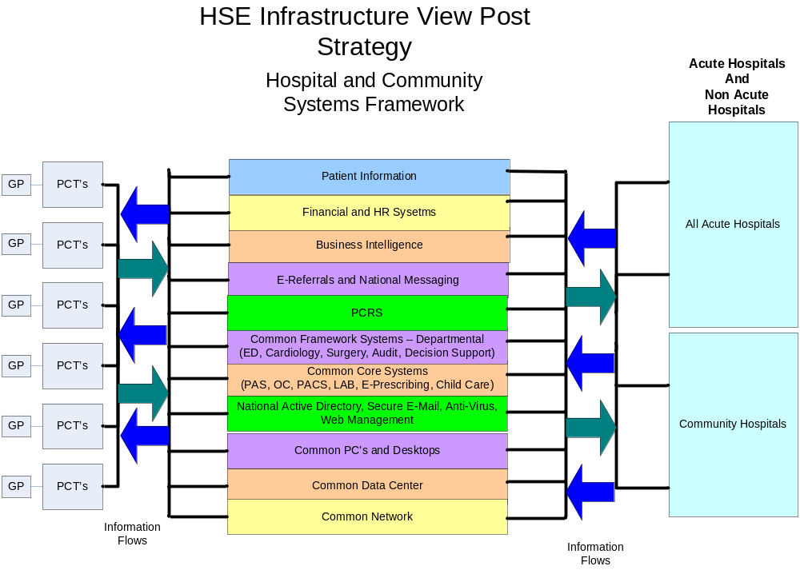

Implementing the ICT Strategy

In order to achieve the desired future state for ICT the strategy will be implemented in five major work streams. The various work streams are illustrated as follows:

Governance
The ICT Steering Committee will be established and oversee and monitor the implementation of the strategy. Executive responsibility for delivery of the ICT strategy will rest with the National Director of ICT.

A multi-year capital plan will be put in place, commencing in 2011, which will set out the capital, revenue and resource implications of the respective programmes. This will be approved through the normal capital planning cycle. All new priorities and projects will be approved by the ICT Steering Committee and delivered through the ICT capital plan.

The delivery of this strategy is entirely dependent on the implementation of a single national ICT delivery organisation and the ability of that team to be able to leverage additional resources as required. The successful delivery of the strategy is also critically dependent on significant business /service line engagement and support.

The governance arrangements established to support the delivery of the strategy must be such that it spans the organisation and, notwithstanding the current staffing embargo, has sufficient authority to make the resources available from all required areas.

Governing Principles
All public sector ICT projects are subject to Department of Finance circular 02/11. To comply with this directive the HSE has agreed the following governing principles.

- One ICT Steering Committee for making priority and activation decisions in relation to all major project proposals – this should ideally be a sub-committee of the senior management team with direct access to the CEO.

- One central source of decision making in relating to implementing ICT strategies, ICT plans and ICT projects who would also be the normal interface for Circular 02/11 purposes with the Department of Health and Children and with the Department of Finance (IS Director)

- Project boards for every significant project, reporting to the ICT Steering Committee and using a project management methodology chosen by the HSE and using the capital appraisal guidelines issued by the Department of Finance

- Compliance with 02/11 (and subsequent) delegation sanction requirements for all ICT spend, regardless of the source of funding

- A peer review gateway process in place for all major projects

- One central management point under the control of the IS Director for all purchases of hardware, software, telecommunications, ICT development or advisory services in all of the HSE including hospitals, medical centres etc. under its funding control

- No further delegation of ICT spending authority within the HSE

- All ICT development staff and ICT operational staff under the control of the IS Director

- All hiring decisions in relation to ICT contractors and ICT consultants under the control of the IS Director, regardless of funding sources

- All tenders for ICT products or services to be approved and advertised by the IS Director and in compliance with a specific 02/11 sanction

- All HSE developments to comply with central guidelines - actual or emergent - e.g. the Public Service Broker, identity management principles and guidelines, shared services, open source software, CMOD technical guidelines, data centres, central framework contracts, telecommunications, collaboration technologies, peer-review mechanisms, national purchasing strategies, central certified training strategies, use of external ICT assistance, asset management etc.

Funding
The future funding model will be based on a multi-year capital plan that takes account of the capital or one off costs of a project, resources required to implement the project and the ongoing costs of the project. This will be aligned with the approval of the capital plan each year.

The strategy assumes the allocation of ICT capital will remain at €40 million per annum for the lifetime of the strategy. Plans for delivery of initiatives described by the strategy will be developed to stay within that allocation.

The priority for the duration of this strategy is to advance the key strategic priorities such that available ICT funding will be utilised. As the healthcare system starts to develop the business cases for these initiatives further discussions on funding will be required. This will occur through the multi-year ICT capital plan of €40m per year.

While the level of funding of ICT within Ireland remains low, by international standards, the public healthcare system has not spent its capital allocation over the last two years. In the next couple of years, capital funding should not, of itself be an obstacle to the achievement of the strategy.

In order that each of the strategic work streams are supported the following funding allocation model will be implemented for capital funding:

Workstream | % Allocation
National business initiatives | 60%
Regional/local initiatives | 10%
Improving ICT Infrastructure | 15%
Information Framework | 10%
Enhancing our capability | 5%
Total [2011-2014] | 100%
Capital allocation by workstream 2011-2014

Funding for all initiatives must be costed in terms of total cost of ownership as all submission for external sanction will be assessed in accordance with this criteria.

Procurement
The procurement of ICT products and services must be carried out within a framework dictated by the EU, coupled with national public sector rules, and local agency procurement and accounting regulations.

Much of the time consumed in procurement results from the ICT system’s acquisition life cycle. Detailed specifications against which tendered products must be assessed have to be developed. EU procurement rules with in-built elapsed times have to be accommodated. Personnel from the ICT and the direct health service delivery units have to be released to assist in developing specifications and assessing tenders. Contracts must be negotiated and converted into legally enforceable instruments. Such a considerable timeframe brings significant challenges to ensure the duration of the procurement does not undermine the applicability of the selected products or services to meet the business needs, as the original need or priority may have changed while the procurement proceeded.

These issues have been compounded in the past by the extent to which scope and requirements differ across agencies, even where ICT support for the same business processes is being procured.

Smaller agency by agency procurement projects that take place outside of a strategic framework require significant overall effort if they are repeated from scratch in other agencies, and cannot maximise overall value for money or forge an integrated ICT environment.

To streamline future procurements, a number of approaches will be adopted. In line with recent practice, future effort will be directed to enterprise-wide procurements. These will use structured, standardised and repeatable techniques and will provide the opportunity for achieving greater overall value.

Framework contracts and enterprise licensing will be used, within which an enterprise-wide business arrangement can be negotiated, enabling variations of product or services at an individual agency level to be accommodated.

These approaches will be built into an ICT procurement policy at an early date. This policy will provide structured support for the procurement of the large scale programmes of work going forward.

Staffing
Availability of skilled ICT staff to ensure delivery of the strategy is a critical issue. There are increasing pressures to make staff available for front line services whilst at the same time, direction from Government to grow ICT capability internally and become more self sufficient. The current moratorium on hiring staff combined with lack of funding for training creates additional issues and risk.

Clearly these issues and risks will have to be managed and the ICT Steering Team must take ownership of them as part of their remit to deliver the ICT Strategy.

Projects
All future ICT developments will follow a standard project lifecycle approach. The lifecycle sets out an approach dealing with four major stages as follows:-

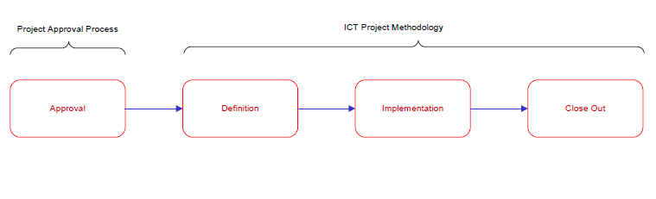

ICT Project Approval Process
All projects are subject to a formal project approvals process. The ’ICT Project Approval Framework’ process ensures that proposals are supported by a comprehensive business case, are aligned with the strategy, are important to the individual directorates and to the HSE and have financial and staff resources committed and available. The ‘ICT Project Approval Framework’ process includes steps to address both internal (HSE) and external (Dept of Health, Dept of Finance) approval and sanction requirements.

High value projects (>5m Euro) are also subject to the public sector peer review process.

ICT Project Methodology
The ICT Directorate has developed a standard Project Management Methodology that covers project initiation, execution and close out. The purpose of the methodology is to support safe and consistent delivery of projects.

The methodology is
- Based on an industry standard (‘Prince2’)
- Scaleable
- Integrates with the ICT Project Approval Framework process
- Integrates with the HSE Programme Delivery Systems
- Simple, practical and straight forward to use.

The following is a detailed view of the Project management methodology process with the corresponding templates associated with each step in the process:

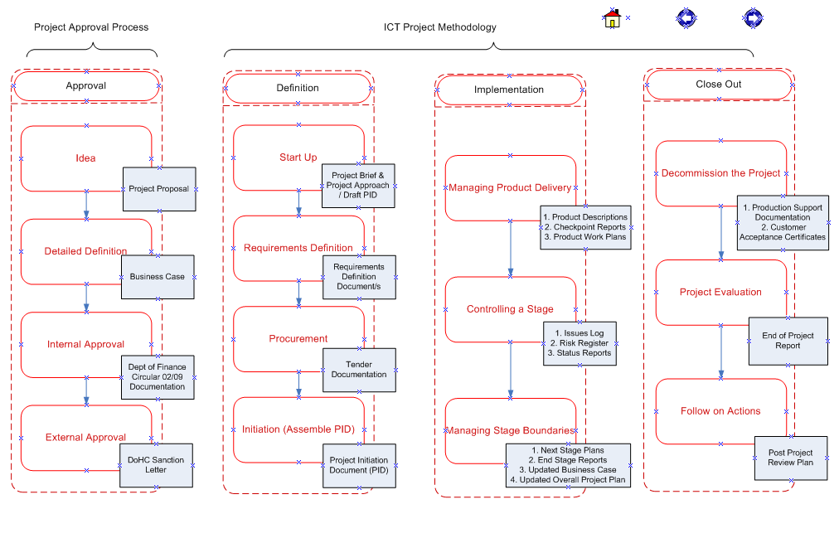

Project Governance
Project governance, appropriate stakeholder engagement and project resourcing continues to be the single most important factor influencing the success of ICT projects deployed within the HSE. Successful delivery of initiatives identified by the strategy will, therefore, be dependent on appropriate governance being in place organisationally as well as at an individual programme or project level.

Projects will therefore operate in accordance with the agreed project lifecycle and all will report to and be monitored by the programme management office within the ICT directorate.

For every project, there will be a:
- Project Sponsor
- Project Board
- Project Manager
- Project Team

Projects may also have a clinical director appointed as appropriate.

The project sponsor will be responsible for realisation of the business benefits.

The seniority of staff assigned to roles within the project board must be commensurate with the scale, value and level of risk associated with each project. The ICT Programme office can provide guidance in this regard.

Proposals for new projects and initiatives will be made to the ICT Programme Office who will identify, track and manage them on behalf of the ICT Steering Committee.

Ultimately, the ICT Steering Committee will decide, on behalf of the HSE, which initiatives will be pursued. All projects must be validated for strategic alignment before being submitted for external approval.

ICT Programme Management Office
The ICT programme management office (PMO) is now established. It’s strategic objectives are:
- To bring consistency to how ICT projects are approved and delivered

- To ensure ICT capital funding is sanctioned, allocated and managed correctly

- To establish an agreed ICT strategy and ensure all projects are aligned with that strategy

Ownership of projects remains with individual project managers and responsibility for benefits remains with the project sponsor. With the portfolio of ICT projects likely to increase significantly as the strategy is implemented, the role of the PMO is to provide a co-ordinating function, to maintain the project register (key details on all projects approved), a programme level dashboard, to maintain the project approval framework process and the project methodology and to provide guidance and advice on the practical application of same.

Delivering Benefit
This strategy is concerned with enabling improved healthcare delivery. It is to be delivered largely by means of a series of major projects and the benefits should be realised though utilisation of a standard benefits realisation process. This will ensure that benefits are defined and monitored within each project. In each case, the project sponsor is responsible for realising benefits and the achievement of the benefits will be monitored in a number of different ways by:

- HSE Management Team through quarterly reporting on agreed strategic priorities
- ICT Steering Committee on progress with the implementation plan
- Each project through the project sponsor at agreed key milestones

Risk Management
The major risk to be addressed is that the components of the strategy progress too slowly and fail to deliver the expected benefits within a reasonable timeframe. Among the risks to be managed to achieve a successful outcome to the strategy are the following;-
- progress may be constrained by capacity and capability to undertake the range of projects being proposed
- in some instances specific expertise is required and this may be difficult to acquire and deploy;
- in some initiatives it may be difficult to get clinician and business commitment to the business changes required;
- for some initiatives there may not be a sufficient degree of process standardisation to enable a successful implementation of a computer-based solution.

The approach to mitigate these risks will be to operate the project approval framework rigorously and to maintain concentration on achieving business benefits. A risk register will be maintained for implementation of the ICT strategy and it will be reviewed each quarter by the ICT Steering Committee.

Implementation plan
A plan has been developed to indicate the timing of key milestones that must be achieved for successful delivery of this ICT Strategy. Timing is dependent on approval of the ICT strategy, appointment of the ICT Steering Committee, allocation of key staff and sanction of relevant projects.

